AM000-Asia-Mongolia-Liaoning-Two Phoenix-Jade-1350 CE

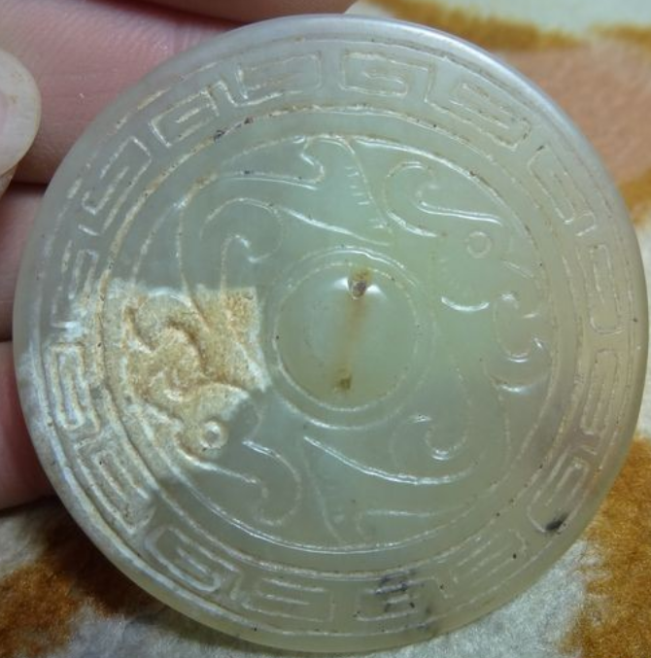

Mongolian Mirror, Liaoning Province, Jade, 2 Phoenixes within a stylized cloud motif symbolizing eternity, ca. 14th century.

Size: 50mm. dia. x 5 mm. thickness.

**Liaoning** 遼寧 is a northeast province of the People's Republic of China, named for the Liao River that flows through the province and "Níng" which means "peace." This mirror carved from a serpentine jade is of Mongolian manufacture based on its iconography and may have been produced by the Mongolian peoples who controlled the Liaoning area prior to the period when the Ming Empire took control of Liaoning in 1371, just three years after the expulsion of the Mongols from Beijing. It may have been attached to a Mongolian's shamans cape that was usually adorned with mirrors to reflect his ascent to the upper-world of the spirits.